# Layer 3 Switch-DHCP across multiple VLANS

1. Introduction:

a layer 3 switch combines the functionality of a switch and a router. It can support routing protocols, inspect incoming packets, and can even make routing decisions based on the source and destination addresses.

1. Objective

Creating a network with layer 3 switch and Implementing DHCP across the Virtual Lans.

1. Interfacing

|  |  |  |  |
| --- | --- | --- | --- |
| Device | Port | IP | SNM |
| MLS | Fa 0/4  Fa 0/5 | 192.168.1.1  201.150.10.102 | 255.255.255.0  255.255.255.0 |
| Router0 | Fa 0/0 | 201.150.10.101 | 255.255.255.0 |
| Server | Fa 0 | 192.168.1.2 | 255.255.255.0 |

1. Lab Design

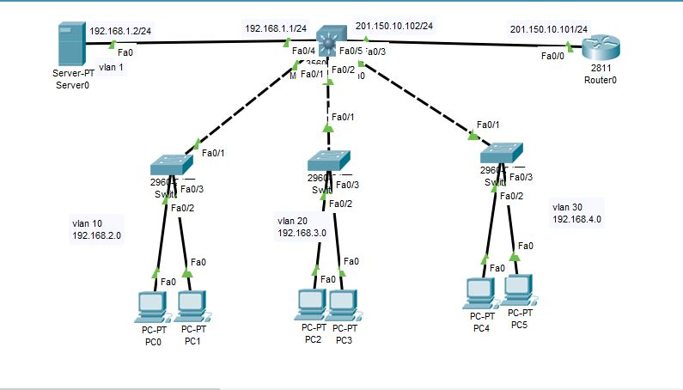

1. Server config:

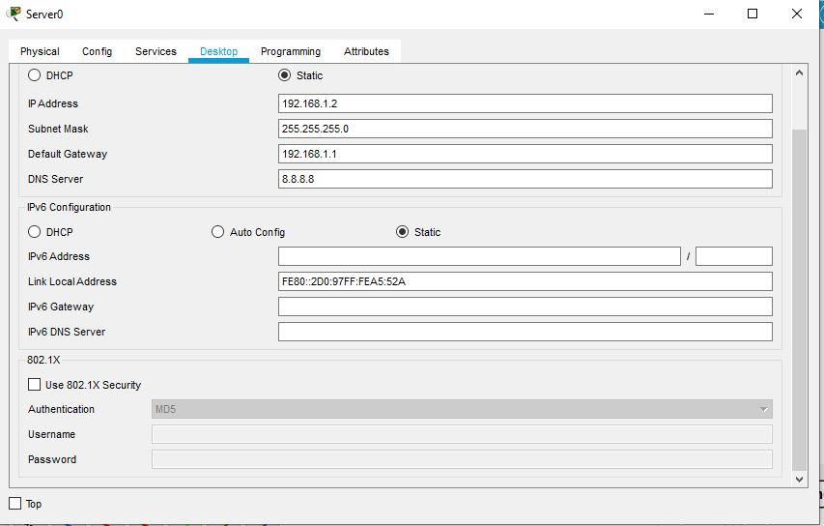

DHCP POOL

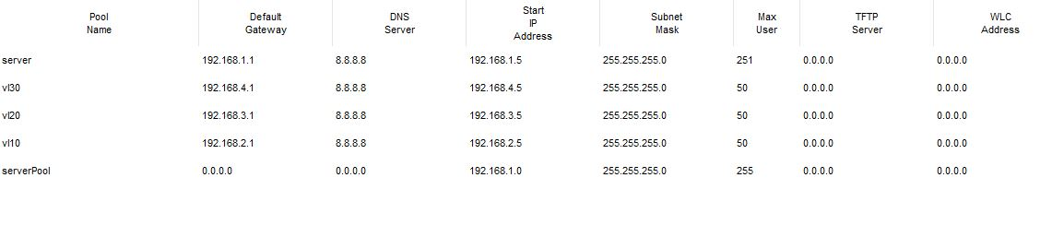

1. Configuration on devices:

At first, we configured the multilayer switch.

MLS(config)#interface fastEthernet 0/4

MLS (config-if)#no sw

MLS(config-if)#no switchport

MLS(config-if)#ip address 192.168.1.1 255.255.255.0

MLS(config-if)#no sh

MLS(config-if)#ex

MLS(config)#vlan 10

MLS(config-vlan)#vlan 20

MLS(config-vlan)#vlan 30

MLS(config-vlan)#ex

MLS(config)#interface vlan 10

MLS(config-if)#ip address 192.168.2.1 255.255.255.0

MLS(config-if)#no sh

MLS(config-if)#ex

MLS(config)#interface vlan 20

MLS(config-if)#ip address 192.168.3.1 255.255.255.0

MLS(config-if)#no sh

MLS(config-if)#ex

MLS(config)#interface vlan 30

MLS(config-if)#ip address 192.168.4.1 255.255.255.0

MLS(config-if)#no sh

MLS(config-if)#ex

MLS(config)#interface fastEthernet 0/1

MLS(config-if)#switchport trunk encapsulation dot1q

MLS(config-if)#switchport mode trunk

MLS(config)#interface fastEthernet 0/2

MLS(config-if)#switchport trunk encapsulation dot1q

MLS(config-if)#switchport mode trunk

MLS(config)#interface fastEthernet 0/3

MLS(config-if)#switchport trunk encapsulation dot1q

MLS(config-if)#switchport mode trunk

MLS(config)#interface vlan 1

MLS(config-if)#ip helper-address 192.168.1.2

MLS(config-if)#ex

MLS(config)#interface vlan 10

MLS(config-if)#ip helper-address 192.168.1.2

MLS(config-if)#ex

MLS(config)#interface vlan 20

MLS(config-if)#ip helper-address 192.168.1.2

MLS(config-if)#ex

MLS(config)#interface vlan 30

MLS(config-if)#ip helper-address 192.168.1.2

MLS(config-if)#ex

MLS(config)#ip routing

MLS(config)#interface fastEthernet 0/5

MLS(config-if)#no switchport

MLS(config-if)#ip address 201.150.10.102 255.255.255.0

MLS(config-if)#no sh

MLS(config-if)#ex

MLS(config)#ip default-gateway 201.150.10.101

Configuration on Layer 2 switches:

Sw0

Switch(config)#vlan 10

Switch(config-vlan)#vlan 20

Switch(config-vlan)#vlan 30

Switch(config-vlan)#ex

Switch(config-vlan)#exit

Switch(config)#interface range fastEthernet 0/2-3

Switch(config-if-range)#switchport mode access

Switch(config-if-range)#switchport access vlan 10

SW1

Switch(config)#vlan 10

Switch(config-vlan)#vlan 20

Switch(config-vlan)#vlan 30

Switch(config-vlan)#ex

Switch(config)#interface range fastEthernet 0/2-3

Switch(config-if-range)#switchport mode access

Switch(config-if-range)#switchport access vlan 20

SW2

Switch(config)#vlan 10

Switch(config-vlan)#vlan 20

Switch(config-vlan)#vlan 30

Switch(config-vlan)#

Switch(config-vlan)#ex

Switch(config)#interface range fastEthernet 0/2-3

Switch(config-if-range)#switchport mode access

Switch(config-if-range)#switchport access vlan 30

Configuration on router:

Router(config)#interface FastEthernet0/0

Router(config-if)#ip address 201.150.10.101 255.255.255.0

Router(config-if)#no shutdown

Router(config-if)#ex

Router(config)#ip route 0.0.0.0 0.0.0.0 fa 0/0

Router(config)#ex

Router#ping 192.168.2.1

Success rate is 100 percent (5/5), round-trip min/avg/max = 0/0/1 ms

Router#ping 192.168.3.1

Success rate is 100 percent (5/5), round-trip min/avg/max = 0/0/0 ms

Router#ping 192.168.4.1

Success rate is 100 percent (5/5), round-trip min/avg/max = 0/1/8 ms

1. Testing:

* Test for DHCP in hosts

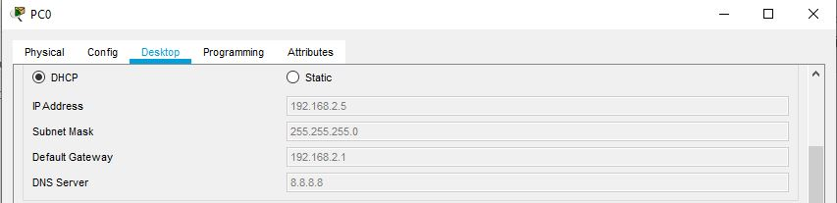

* Ping from pc0 to pc2

